ZDDR-2022-0010001

张店区人民政府
关于划定张店区畜禽养殖禁养区的通告

根据《中华人民共和国环境保护法》《中华人民共和国畜牧法》《畜禽规模养殖污染防治条例》等法律法规要求，结合我区实际，划定畜禽养殖禁养区。现将有关事项通告如下：
- 禁养区是指禁止建设养殖场（小区）或禁止建设有污染物排放的养殖场（小区）的区域。
二、我区畜禽养殖禁养区划定范围为：全市功能区调整优化后，现为张店区管理的西至滨博高速公路、北至济青高速公路、东至东四路、南至海岱大道（马南路）区域（分布图及坐标见附图、附表）。
三、在禁养区内，不得新建畜禽养殖场、养殖小区。已经建成的，按照国家和地方有关规定限期关闭或者搬迁。
四、农业农村、自然资源和规划、生态环境、财政、卫生等部门要密切配合，按照职责做好监督管理工作。
五、本通告自2022年3月1日起施行，有效期至2027年2月28日。自通告实施之日起，本区管理区域内原禁养区相关文件同时废止。
六、本通告发布后，国家和地方发布或修订的法律法规对禁养区有新规定的，按照新规定执行。

淄博市张店区人民政府
2022年1月28日

附图
张店区畜禽养殖禁养区划分范围图
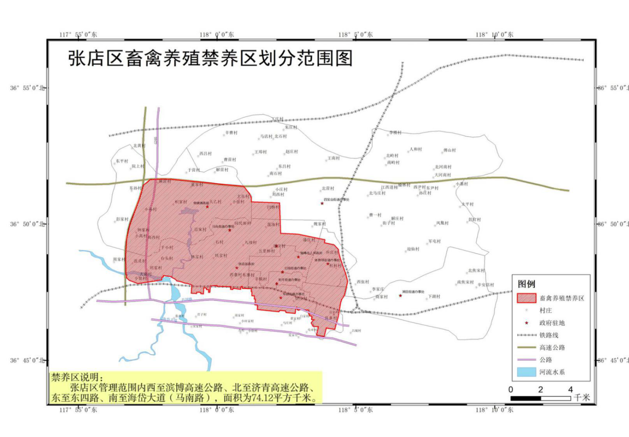

注：具体拐点坐标及拐点范围见附表

附表
张店区畜禽养殖禁养区范围拐点坐标
序号 | 经度 | 纬度 | 序号 | 经度 | 纬度
1 | 118.077276 | 36.80277594 | 61 | 117.9999036 | 36.79561675
2 | 118.0783913 | 36.79815606 | 62 | 117.9959554 | 36.79553092
3 | 118.0762911 | 36.78945672 | 63 | 117.9955906 | 36.79149688
4 | 118.0748773 | 36.78737572 | 64 | 117.9947752 | 36.7915398
5 | 118.0741882 | 36.78529803 | 65 | 117.994861 | 36.79314912
6 | 118.0727291 | 36.77663622 | 66 | 117.9935092 | 36.79329932
7 | 118.0716991 | 36.77299247 | 67 | 117.9935521 | 36.79424346
8 | 118.0706691 | 36.76884574 | 68 | 117.9919428 | 36.79430783
9 | 118.0655212 | 36.76967443 | 69 | 117.9917926 | 36.79063857
10 | 118.0642337 | 36.7645675 | 70 | 117.9901618 | 36.7907244
11 | 118.0596417 | 36.76542581 | 71 | 117.9901618 | 36.79158271
12 | 118.0607575 | 36.77048982 | 72 | 117.9877585 | 36.79166854
13 | 118.0587191 | 36.77065075 | 73 | 117.9876727 | 36.79081023
14 | 118.0576247 | 36.77075804 | 74 | 117.9844112 | 36.79106773
15 | 118.0568308 | 36.7721206 | 75 | 117.9848403 | 36.79604591
16 | 118.0564016 | 36.77287162 | 76 | 117.9820079 | 36.79699004
17 | 118.056745 | 36.77334369 | 77 | 117.9804629 | 36.79716171
18 | 118.0572814 | 36.77396596 | 78 | 117.978918 | 36.79784835
19 | 118.0578822 | 36.77443803 | 79 | 117.9776305 | 36.79819167
20 | 118.0584401 | 36.77478135 | 80 | 117.9757423 | 36.798535
21 | 118.0566377 | 36.77499593 | 81 | 117.9751414 | 36.79930747
22 | 118.0568523 | 36.77701295 | 82 | 117.9742831 | 36.79990829
23 | 118.0553931 | 36.77712024 | 83 | 117.9730815 | 36.8005091
24 | 118.0555004 | 36.77827895 | 84 | 117.9723949 | 36.80119575
25 | 118.0549425 | 36.77827895 | 85 | 117.9675883 | 36.80179656
26 | 118.0550713 | 36.7806393 | 86 | 117.9675883 | 36.80093826
27 | 118.0492348 | 36.78106845 | 87 | 117.9668159 | 36.80093826
28 | 118.0492562 | 36.78059638 | 88 | 117.966708 | 36.79915895
29 | 118.0483765 | 36.78059638 | 89 | 117.9524315 | 36.79693556
30 | 118.0483979 | 36.78126157 | 90 | 117.9471292 | 36.79894109
31 | 118.0478829 | 36.78126157 | 91 | 117.9453911 | 36.80062203
32 | 118.0478615 | 36.78252757 | 92 | 117.9456534 | 36.80070985
33 | 118.0472607 | 36.78252757 | 93 | 117.9456062 | 36.80247395
34 | 118.0469174 | 36.77870811 | 94 | 117.9451789 | 36.80246485
35 | 118.0412954 | 36.77922309 | 95 | 117.9450766 | 36.81481629
36 | 118.0410379 | 36.78021014 | 96 | 117.9457327 | 36.82453008
37 | 118.0378622 | 36.78051055 | 97 | 117.9474163 | 36.83244117
38 | 118.0370039 | 36.77969516 | 98 | 117.9507296 | 36.8416854
39 | 118.0240435 | 36.78102554 | 99 | 117.9533362 | 36.8489167
40 | 118.024301 | 36.78257049 | 100 | 117.9551511 | 36.85497223
41 | 118.0241078 | 36.78259195 | 101 | 117.9557633 | 36.85721836
42 | 118.0242795 | 36.78368629 | 102 | 117.9574585 | 36.8585747
43 | 118.0226058 | 36.78390086 | 103 | 117.9597759 | 36.86051474
44 | 118.023035 | 36.78741992 | 104 | 117.9668999 | 36.86092677
45 | 118.0222625 | 36.78737701 | 105 | 117.9722858 | 36.86078943
46 | 118.0223483 | 36.78939403 | 106 | 118.0159911 | 36.85634275
47 | 118.0208034 | 36.78947986 | 107 | 118.0194175 | 36.85187003
48 | 118.0208463 | 36.79218353 | 108 | 118.0205119 | 36.84945758
49 | 118.02046 | 36.79218353 | 109 | 118.0205763 | 36.84690769
50 | 118.0205459 | 36.79377139 | 110 | 118.0375385 | 36.84631528
51 | 118.0151385 | 36.79385722 | 111 | 118.0380964 | 36.82763047
52 | 118.0151815 | 36.79514468 | 112 | 118.0465722 | 36.82721825
53 | 118.0142802 | 36.79514468 | 113 | 118.0490613 | 36.8270465
54 | 118.0141515 | 36.79338515 | 114 | 118.0647254 | 36.82371433
55 | 118.0094737 | 36.79402889 | 115 | 118.0643821 | 36.82189361
56 | 118.0093879 | 36.79325641 | 116 | 118.0701542 | 36.82063967
57 | 118.0080575 | 36.79342807 | 117 | 118.0727935 | 36.81778822
58 | 118.0081863 | 36.79505885 | 118 | 118.0730295 | 36.81576119
59 | 118.0038518 | 36.7951876 | 119 | 118.0741024 | 36.81168983
60 | 117.9998178 | 36.79523052 | 120 | 118.077276 | 36.80277594
