2-5-3

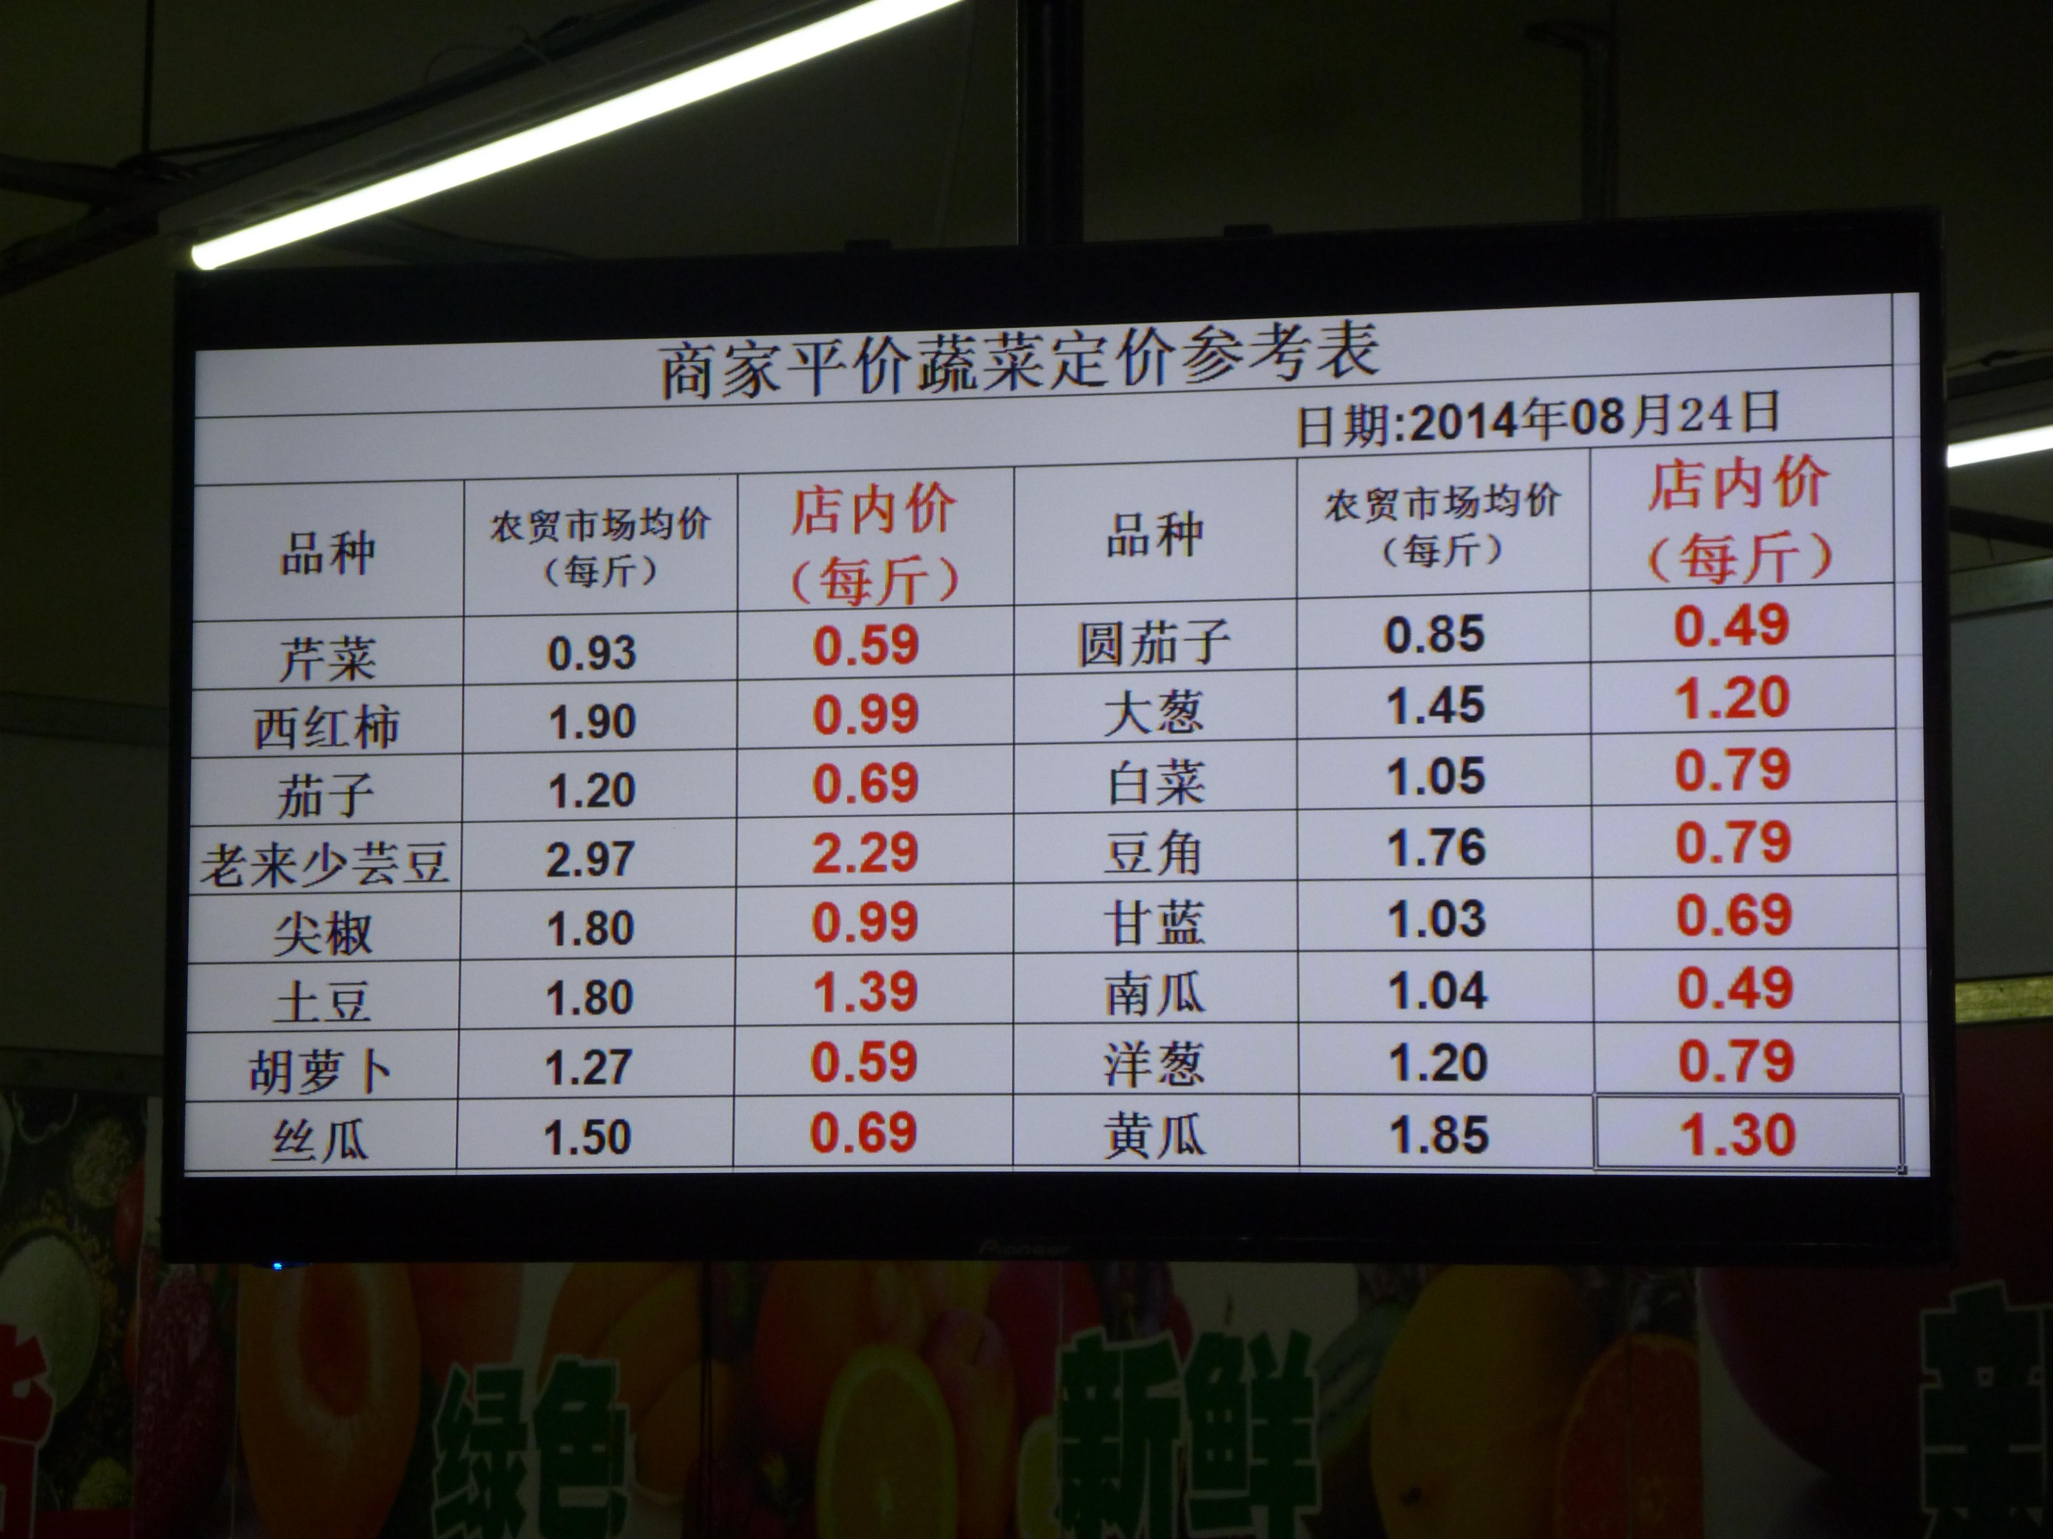

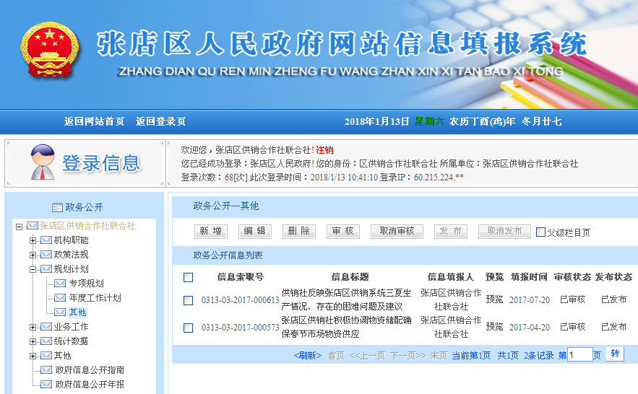

<http://www.zhangdian.gov.cn/wsDesk/InfoOpen/XxtbList.aspx?fnid=1791>

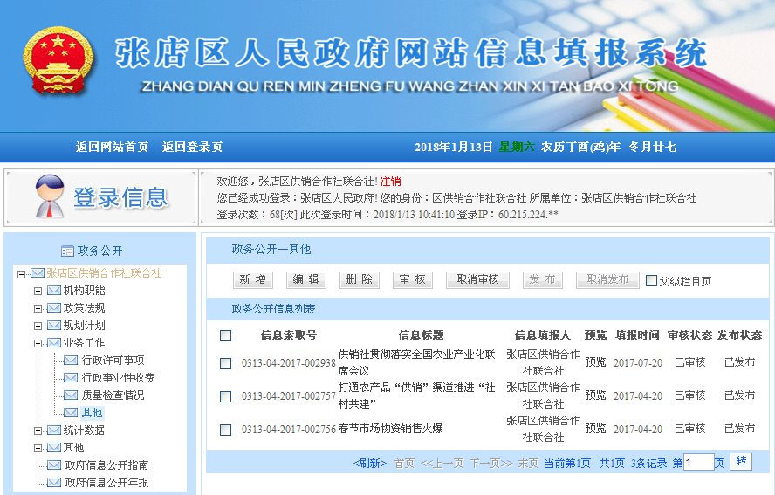

http://www.zhangdian.gov.cn/wsDesk/InfoOpen/XxtbList.aspx?fnid=1795

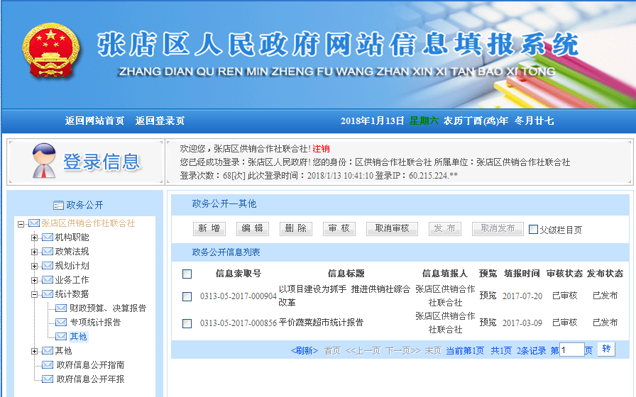

http://www.zhangdian.gov.cn/wsDesk/InfoOpen/XxtbList.aspx?fnid=1798

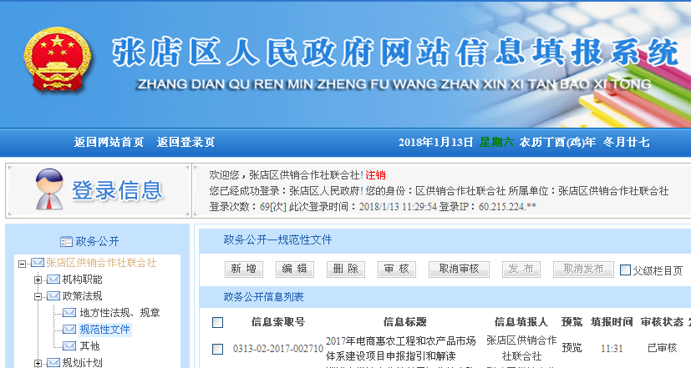

<http://www.zhangdian.gov.cn/wsDesk/InfoOpen/XxtbList.aspx?fnid=1786&pageId=0>